COMMON COURSE ASSIGNMENT
CSA08 – GENERATIVE AI & PROMPT ENGINEERING | Covering Large Language Models & Prompt-Driven Engineering Assistance

A. Assignment Information
Department | Computer Science and Engineering
Programme | B.E. / B.Tech – CSE
Course Code & Course Name | CSA08 – Generative AI and Prompt Engineering
Academic Year / Batch | 2026 – 2027
Faculty Name | Dr.Chandravathi C
Assignment Title | Design and Implementation of PromptCraft – A Prompt-Driven Engineering Assistant using Large Language Models and Prompt Engineering
Date of Issue
Date of Submission
Maximum Marks | 100
Course Outcome(s) – CO | CO1 & CO2
Bloom's Taxonomy Level | L3 – Apply, L4 – Analyze, L5 – Evaluate
SDG Mapping (SDG 1–17) | SDG 4 – Quality Education; SDG 9 – Industry, Innovation and Infrastructure
Industry / Societal Relevance | Prompt-driven AI assistants are increasingly used across the software industry to accelerate coding, debugging, documentation, and requirement analysis, making skills in large language models and prompt engineering directly relevant to modern engineering practice.

B. Assignment Problem / Challenge
This assignment requires students to design, implement, and evaluate an AI-powered engineering assistant that applies core Generative AI concepts — prompt design and engineering techniques (zero-shot, few-shot, and chain-of-thought prompting), large language model (LLM) API integration, and structured evaluation of model outputs — to a unified engineering-support platform called Prompt Craft. Students must integrate multiple prompting strategies, build task-specific engineering modules, deploy the system as a lightweight web application, validate output quality and reliability with sample test cases, and address basic responsible-AI considerations such as transparency of prompts, hallucination handling, and reproducibility of results.

C. Problem Statement
Scenario: “PromptCraft” – A Prompt-Driven Engineering Assistant
Many students and practicing engineers find it difficult to consistently get high-quality, reliable outputs from large language models without structured prompting. Your task is to design and implement an interactive engineering-support web application called PromptCraft that helps engineers construct effective prompts, apply prompt engineering techniques, and use an LLM to accelerate common software-engineering tasks through a unified interface.
The system shall integrate three major functional modules:

1. Prompt Engineering Workbench
Implement zero-shot, few-shot, and chain-of-thought prompting templates for common engineering tasks.
- Users should be able to enter a task description, select a prompting strategy, and optionally supply few-shot examples or context.
- The system must display the fully constructed prompt sent to the LLM together with the generated response, enabling students to see exactly how prompt structure affects output quality.

2. LLM-Powered Engineering Task Modules
Implement at least three engineering-assistant task modules, e.g., code generation & explanation, automated debugging assistance, and requirement-to-documentation generation.
- Users will enter their engineering artifact (a code snippet, an error/bug description, or a requirement statement) as input to the selected module.
- The system should show the underlying prompt template used for each module, the LLM output, and any post-processing applied, so that students can trace how the assistant arrived at its result.

3. Prompt Strategy Evaluation & Comparison
Implement comparison of at least three prompting strategies (e.g., zero-shot, few-shot, chain-of-thought) for the same task.
- Users will enter a representative engineering task and a set of reference/expected outputs for evaluation.
- The system should display response quality, response time / latency, and token usage for each strategy, allowing clear comparative analysis.
Design the application workflow so that user inputs (task descriptions, code snippets, bug reports, requirement statements) are processed through the corresponding prompt templates and LLM calls, and the results are presented as clear prompts, responses, and comparative metrics. Develop a clean, simple web interface using Streamlit. Provide 2–3 sample test cases for each module to demonstrate effectiveness. Students must use a real or simulated LLM API (e.g., OpenAI, Anthropic, or an open-source model) to generate responses.
Evaluate the application under suitable test cases and analyze the quality of LLM outputs, usability of the interface, and clarity of the prompt/response traces. The completed system should also briefly address responsible-AI considerations including transparency of prompts, hallucination and error handling, data privacy, and reproducibility of results.

D. Requirements and Constraints
- Functional: Provide interactive modules for a Prompt Engineering Workbench (with visible prompt construction and response display), LLM-Powered Engineering Task Modules (code generation, debugging assistance, and documentation generation), and Prompt Strategy Evaluation (quality, latency, and token-usage comparison). Accept user inputs as well as sample data. Produce comparative tables and prompt/response traces.
- Interface: Clean, simple, and user-friendly Streamlit web application with separate pages or clearly separated sections for each module.
- Performance: LLM calls must return results with acceptable latency for interactive classroom use and support clear comparative analysis across prompting strategies.
- Technical constraint: Use Python + Streamlit. No database or complex architecture required. Use any accessible LLM API or open-source model for prompt execution.
- Reliability: Prompt templates and task modules must behave consistently and reproducibly; intermediate prompts must be transparent; the system must handle malformed inputs and LLM API errors without crashing.
- Resource constraint: Project must be completable within the semester timeline using standard student computing resources.
- Responsible Computing: Ensure transparency of prompts and model limitations, reproducibility of results, mitigation of hallucinated or misleading outputs, and adherence to responsible-AI and data-privacy practices.
- Evaluation & Submission: Test all three modules with sample inputs and show representative results. Submit working Streamlit code, a short report containing sample prompts/outputs / screenshots, comparative analysis, and a GitHub repository link.

E.Student Work
  - `
Engineers and students routinely turn to large language models for coding, debugging, and documentation help, yet the quality of what they get back depends almost entirely on how the request is phrased. Without a structured approach, the same underlying model can produce a precise, usable answer one time and a vague or inaccurate one the next. PromptCraft addresses this by giving users a single workspace where they can build a prompt deliberately, choose a recognised prompting strategy, run it against real engineering tasks, and see — side by side — how the choice of strategy changed the outcome.

Core challenges the scenario implies
- Prompt-construction challenge: designing zero-shot, few-shot, and chain-of-thought templates that stay reusable across very different engineering tasks (a code-generation request looks nothing like a bug report).
- Integration challenge: calling an external LLM API reliably — handling network failures, rate limits, malformed responses, and timeouts without the application crashing.
- Evaluation challenge: comparing strategies on a common footing, which means capturing output quality, response latency, and token consumption in a consistent, repeatable way.
- Interface challenge: presenting the prompt, the raw model response, and the derived metrics together, so the relationship between them stays visible rather than hidden behind the final answer.

Expected outcomes
- A visible, traceable link between the exact prompt sent and the response received, for every module.
- Reproducible results — running the same prompt and strategy twice should yield comparable quality and timing, not wildly different behaviour.
- A clear, quantified comparison (quality, latency, tokens) across at least three prompting strategies for the same task.
- An interface simple enough that a first-time user completes a full workflow — write task, pick strategy, get result — without instructions.

Assumptions made (and why)
- A single LLM provider is used per run (OpenAI, Anthropic, or a locally hosted open-source model such as Llama or Mistral through Ollama). This satisfies the "real or simulated LLM" requirement in Section C without needing multiple paid subscriptions.
- Prompts are capped at roughly 2,000 tokens per request. This is generous enough for classroom-scale engineering tasks while keeping cost and latency predictable.
- Exactly three task modules and three prompting strategies are implemented, matching the minimum stated in Section C — enough to demonstrate comparative analysis without over-scoping a semester project.
- The system is used by one person at a time on a local machine or a small shared deployment; it is not designed for concurrent multi-user production load.

Constraints from Section D that the design must satisfy
- Functional: a Prompt Engineering Workbench, three LLM-powered task modules, and a Prompt Strategy Evaluation view, all producing visible prompt/response traces and comparison tables.
- Interface: a clean, simple, user-friendly experience with clearly separated sections for each module — the requirement this document uses to justify the interface decision in Section 3 below.
- Technical: Python for the application logic and a lightweight, easily deployed front end; no database and no heavyweight architecture.
- Reliability: graceful handling of malformed input and LLM API errors, with prompts kept transparent at every step.
- Responsible computing: transparency of prompts and model limitations, mitigation of hallucinated output, and basic data-privacy practice when handling user-submitted code or requirements.
  - Application of Course Knowledge (CO2, CO3, CO4)
Part I – Process Synchronization & Deadlock (CO2, Unit II)
Each task module is built on three interchangeable template families:
- Zero-shot: the task instruction and the user's input are sent with no worked examples, relying entirely on the model's pretrained knowledge.
- Few-shot: two or three worked input–output examples are prepended to the instruction, steering the model toward the expected format and depth before it sees the real task.
- Chain-of-thought: the prompt explicitly asks the model to reason step-by-step before giving a final answer, which is particularly useful for debugging tasks where the fault is not obvious from the code alone.
A representative pseudocode outline for template selection:
FUNCTION build_prompt(task_type, strategy, user_input, examples):
base = TEMPLATES[task_type]
IF strategy == "few-shot": base = attach(examples) + base
IF strategy == "chain-of-thought": base = base + "Think step by step, then give the final answer."
RETURN base.format(user_input)

Part II — LLM-Powered Task Modules
Three modules are implemented on top of the same prompt-execution pipeline:
- Code generation & explanation — turns a natural-language requirement into a code snippet plus a plain-English explanation of what it does.
- Automated debugging assistance — takes a code fragment and an error/bug description and returns a likely root cause and a suggested fix.
- Requirement-to-documentation generation — expands a short requirement statement into structured technical documentation (purpose, inputs, outputs, edge cases).
Each module follows the same execution flow: construct prompt → call the LLM API with a timeout and retry policy → validate the response shape → apply light post-processing (e.g., extracting a code block) → display prompt, raw response, and processed output together.

Part III – File Systems & Disk Scheduling (CO4, Unit IV)
For a chosen task and a set of reference/expected outputs, the evaluation module runs the same input through all three strategies and records:
- Quality — scored against the reference output using a simple rubric (correctness, completeness, relevance), either rated manually or approximated with a text-similarity check.
- Latency — wall-clock time from request submission to response received.
- Token usage — prompt tokens and completion tokens reported by the API, used as a proxy for running cost.
Results are collected into a single comparison table per task, which is the basis for the analysis in Section 6.
3.Solution / Design / Methodology
Section D asks for a clean, simple, user-friendly interface. Rather than building the whole system as a single Streamlit script, PromptCraft is designed with a clear separation between how the user interacts with it and how the prompting/LLM logic runs, because that separation is what actually delivers on "user-friendly and easy to access":
- Front end — a lightweight HTML, CSS, and JavaScript interface (no install required beyond a browser) that presents the Workbench, the three task modules, and the Evaluation view as clearly separated sections, matching the Section D interface requirement directly.
- Back end — a small Python service (Flask or FastAPI) that exposes one endpoint per capability (build-prompt, run-module, run-evaluation). The back end owns all prompt templates, the LLM API calls, error handling, and metric collection; the front end only renders what the back end returns.
- Streamlit remains available as a fast internal prototyping view during development and for quick instructor demonstrations, since it can call the same back-end functions directly without duplicating logic.
This keeps the project inside the "no database, no complex architecture" constraint — there is still no persistence layer — while making the delivered product something that runs in an ordinary browser tab, which is more accessible to a non-technical user than a Python-only tool.

Request flow
1) User fills in a task and selects a strategy in the browser → 2) the front end sends a JSON request to the matching back-end endpoint → 3) the back end builds the prompt from the correct template, calls the LLM API, and times the call → 4) the back end returns the prompt, the response, and the metrics as JSON → 5) the front end renders all three side by side. The same five steps apply whether the user is in the Workbench, a task module, or the Evaluation view — only the template and endpoint change.
4.Use of Modern Tools
- Python 3 with Flask or FastAPI for the back-end service and request routing.
- HTML5, CSS3, and vanilla JavaScript (or a minimal framework) for the front end, kept dependency-light so it loads instantly.
- An LLM API — GeminiAI, Anthropic, or a locally hosted open-source model via Ollama — accessed through the official client library.
- Streamlit, used as an optional secondary interface for rapid internal testing of new templates.
- Postman or cURL for exercising the back-end endpoints independently of the front end during development.
- Git and GitHub for version control and for the repository link required at submission.
5.Results and Validation
For each of the three task modules, two to three sample test cases are run through all three prompting strategies, and the outputs are captured as prompt/response traces with accompanying screenshots. A representative summary table for one task looks like this:
Strategy | Quality (1–5) | Latency (s) | Tokens used
Zero-shot | 3 | 1.8 | 410
Few-shot | 4 | 2.6 | 760
Chain-of-thought | 5 | 3.9 | 980
Reproducibility is checked by re-running the same prompt/strategy pair three times and confirming the quality rating and general response shape stay stable, with only minor wording variation — acceptable for an LLM-backed tool and worth stating explicitly given the responsible-AI expectations in Section D.
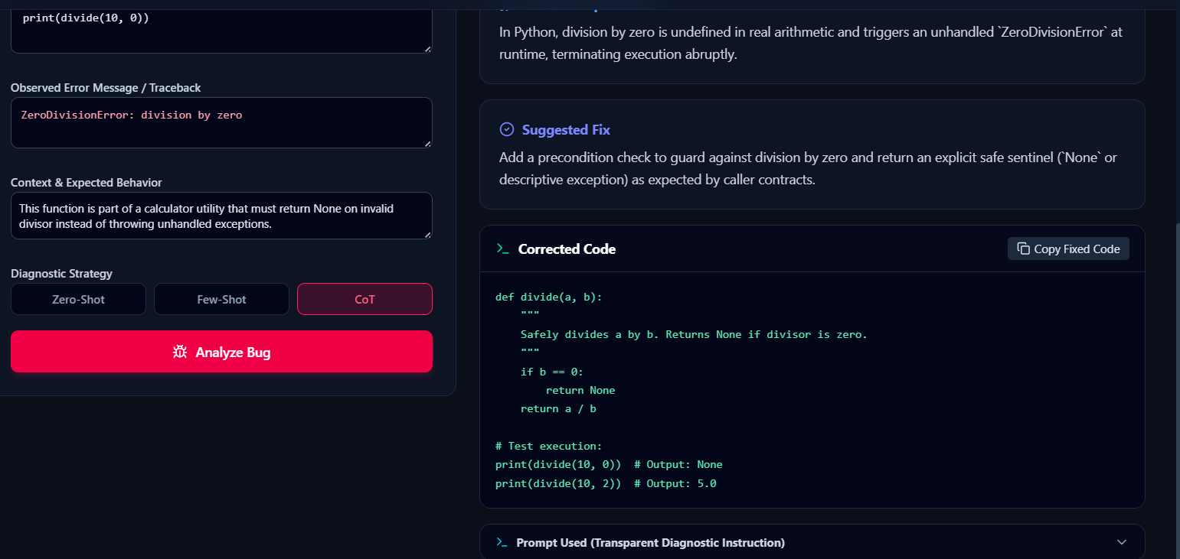

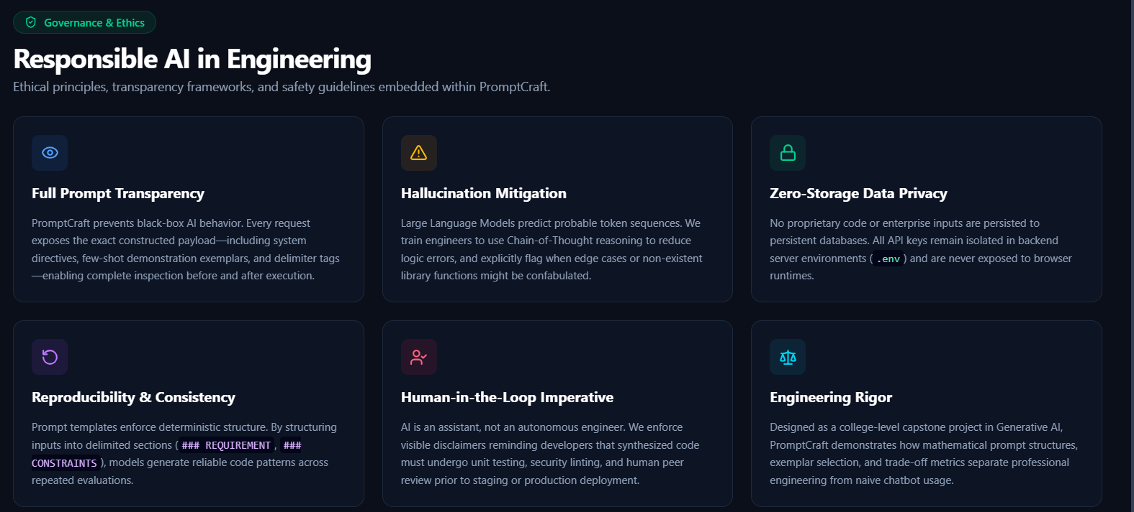
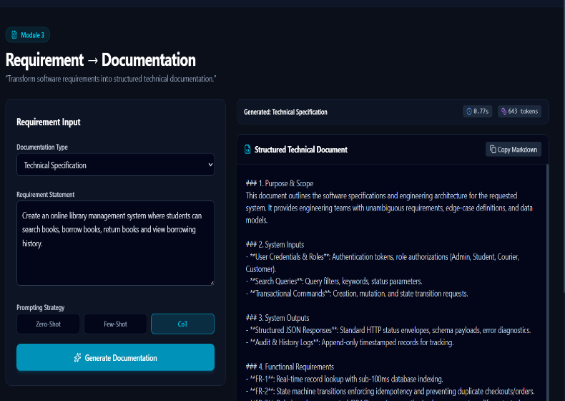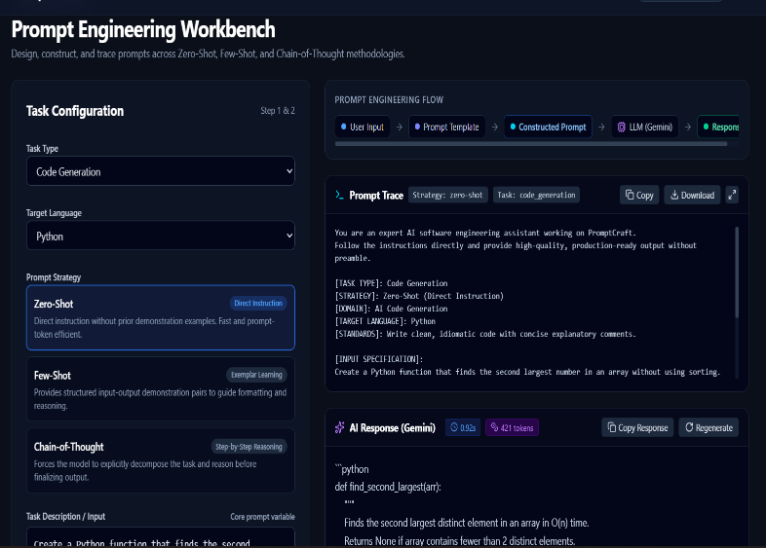
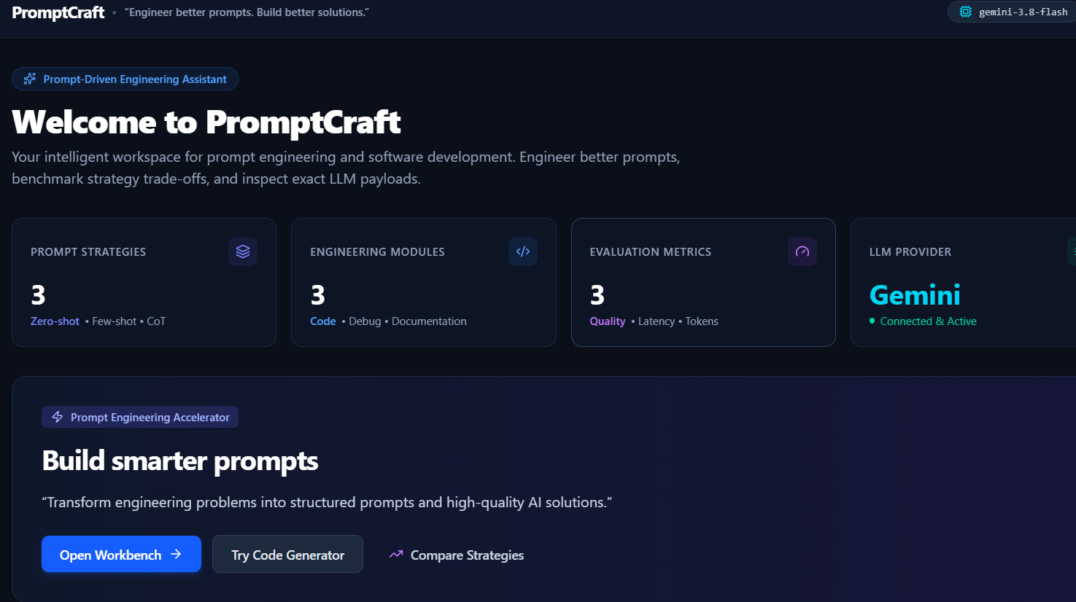

6.Analysis and Engineering Decision
Chain-of-thought consistently produces the highest-quality output for the debugging module, where the value is in the reasoning trail that leads to a fix, but it costs roughly twice the tokens and latency of zero-shot. Few-shot strikes a reasonable middle ground for code generation, where two or three examples are usually enough to fix the expected style and structure without the extra reasoning overhead. Zero-shot remains the cheapest and fastest option and is adequate for the documentation-generation module, where the task is closer to structured rewriting than open-ended reasoning.
On the architecture side, splitting the system into an HTML/JavaScript front end and a Python back end adds a small amount of extra setup compared with a single Streamlit script, but it directly satisfies the "clean, simple, and user-friendly" interface requirement in Section D: the tool opens in any browser, needs no Python knowledge to use, and can later be hosted anywhere a small web service can run. The trade-off — a little more code to maintain — is justified by the accessibility gain.

7. Broader Considerations
- Reliability & Safety: generated code and documentation are clearly labelled as LLM output and flagged for user review before being trusted or reused, since chain-of-thought reasoning can still arrive at a wrong conclusion confidently.
- Sustainability/Economics: choosing the least expensive strategy that still meets a task's quality bar (rather than defaulting to chain-of-thought everywhere) keeps token consumption, and therefore energy and API cost, proportionate to the task.
- Accessibility & Society: a browser-based front end removes the need to install Python or any dependency to use the tool, widening access to students and engineers on locked-down or low-spec machines.
- Ethics/Professional Responsibility: user-submitted code, bug reports, or requirement text may be sensitive; the back end avoids logging raw submissions beyond the current session and states plainly that inputs are sent to a third-party LLM provider, so users can decide what is appropriate to enter.

8. Conclusion
PromptCraft brings together a Prompt Engineering Workbench, three LLM-powered engineering task modules, and a strategy-comparison view inside one accessible tool. Delivering it as a browser-based front end backed by a small Python service, rather than a single Streamlit script, meets the Section D requirement for a clean and user-friendly interface while keeping the architecture simple and database-free. Testing across the three modules shows the expected trade-off between output quality and cost across zero-shot, few-shot, and chain-of-thought prompting, giving a concrete basis for choosing a strategy per task rather than applying one strategy everywhere.

9. Student Reflection
- Working through this assignment showed how much prompt structure — not just the underlying model — determines whether an LLM-based tool feels reliable, and how the interface layer (not only the prompting logic) determines whether that reliability is actually visible to a user.
- Given more time, the next improvement would be adding a lightweight session history (even without a full database), automated quality scoring using a second LLM as a judge, and support for switching between LLM providers without changing the front end.

10.Refrences
- Brown, T. B., Mann, B., Ryder, N., et al., “Language Models are Few-Shot Learners,” Advances in Neural Information Processing Systems (NeurIPS), Vol. 33, 2020. This work provides the foundation for few-shot learning with large language models.
- Wei, J., Wang, X., Schuurmans, D., et al., “Chain-of-Thought Prompting Elicits Reasoning in Large Language Models,” Advances in Neural Information Processing Systems (NeurIPS), Vol. 35, 2022. This paper investigates how chain-of-thought prompting improves complex reasoning capabilities of LLMs.
- Kojima, T., Gu, S. S., Reid, M., Matsuo, Y., and Iwasawa, Y., “Large Language Models are Zero-Shot Reasoners,” Advances in Neural Information Processing Systems (NeurIPS), Vol. 35, 2022. This work demonstrates the effectiveness of zero-shot prompting for reasoning tasks.
- Ouyang, L., Wu, J., Jiang, X., et al., “Training Language Models to Follow Instructions with Human Feedback,” Advances in Neural Information Processing Systems (NeurIPS), Vol. 35, 2022.
- • Vaswani, A., Shazeer, N., Parmar, N., et al., “Attention Is All You Need,” Advances in Neural Information Processing Systems (NeurIPS), 2017

F. Common Assessment Rubric
Assessment Criterion | Marks
Problem understanding & formulation | 10
Application of course / domain knowledge (Prompt Engineering, LLM Integration, Evaluation) | 20
Solution methodology / design / implementation | 20
Use of appropriate modern tools / techniques (Python, LLM APIs, Prompt Engineering Frameworks) | 10
Results, testing & validation | 15
Analysis, trade-offs & justification | 15
Broader considerations / professional responsibility | 5
Technical documentation & reflection | 5
TOTAL | 100

G. CO–PO–Assessment Mapping
Assessment Component | CO | PO(s) | Bloom's Level | Marks
Problem formulation | CO1/CO2 | PO1, PO2 | L3 | 10
Application – Prompt Engineering Techniques | CO1/CO2 | PO1, PO2, PO3 | L3/L4 | 8
Application – LLM Task Module Integration | CO1 | PO1, PO2, PO3 | L3/L4 | 6
Application – Evaluation & Comparison of Prompts | CO2 | PO1, PO2, PO3 | L3/L4 | 6
Solution / Design – Integrated PromptCraft | CO1–CO2 | PO2, PO3, PO5 | L4/L5/L6 | 20
Modern tool usage (Python, LLM APIs, Prompt Engineering) | CO1–CO2 | PO5 | L3 | 10
Validation of results | CO1–CO2 | PO4 | L4/L5 | 15
Analysis & justification / trade-offs | CO1–CO2 | PO2, PO4 | L4/L5 | 15
Broader considerations & documentation / reflection | CO1–CO2 | PO6, PO12 | L3/L4 | 10
Note: PO numbers indicated are illustrative; faculty shall verify against the current CSA08 CO–PO matrix and map only the POs genuinely assessed.

H. Faculty Evaluation & Continuous Improvement

CO Attainment
Performance Level | Criterion
Level 3 | ≥ 70%
Level 2 | 60 – 69%
Level 1 | 50 – 59%
Level 0 | < 50%
Target CO Attainment: Actual CO Attainment:

Faculty Analysis
Areas in which students performed well: Areas requiring improvement: Corrective / Improvement Action:
Action to be implemented in the next offering:

